# **Lab 06: Data model and model-driven app**

In this lab you will be implementing the data model for the solution and building a model-driven app that will be used by anyone fixing problems or managing the overall effort.

## What you will learn

* Create Tables, Columns, and relationships
* Create a model-driven app
* Create a site map
* Create and configure Table forms
* Create and configure Table views

## High-level lab steps

* Exercise 1 – Create publisher and solution
* Exercise 2 – Implement the data model
  + Data Model
    - Building
    - Department
    - Problem Report
* Exercise 3 – Configure forms and views
* Exercise 4 – Compose a basic model-driven app
* Exercise 5 – Input data and refine some views, import some problem reports

## Detailed steps

### Exercise 1: Create publisher and solution

In this exercise, you will create a custom solution publisher and a solution. This custom solution will be used in all the labs for this course to keep all the assets together.

#### **Task 1: Create publisher and solution**

1. Navigate to the [Power Apps maker portal](https://make.powerapps.com/) and make sure you are in the practice environment you created.
2. Select **Solutions** and click **+ New solution**.
3. Enter **Company 311** for **Display name**.
4. Click on the **Publisher** dropdown and select **+ Publisher**.

[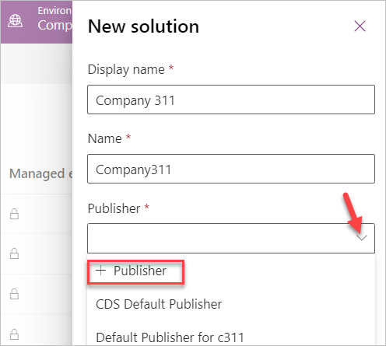](https://github.com/MicrosoftLearning/PL-100-Microsoft-Power-Platform-App-Maker/blob/master/Instructions/Labs/02/media/image1.png)

1. Enter **Lamna Healthcare** for **Display name**, **lh** for **Prefix**, and click **Save and Close**.

[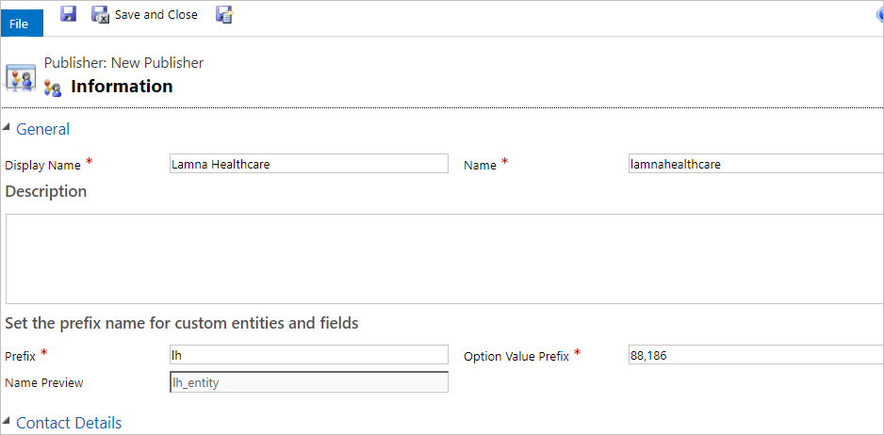](https://github.com/MicrosoftLearning/PL-100-Microsoft-Power-Platform-App-Maker/blob/master/Instructions/Labs/02/media/image2.png)

1. Click **Done** on the popup.
2. Click on the **Publisher** dropdown again and select the **Lamna Healthcare** publisher you created.
3. Click **Create**.

[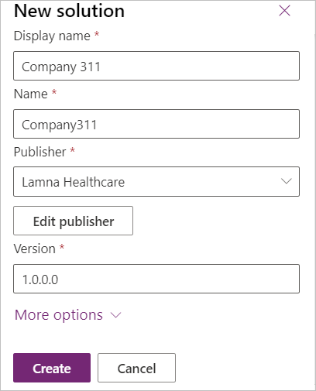](https://github.com/MicrosoftLearning/PL-100-Microsoft-Power-Platform-App-Maker/blob/master/Instructions/Labs/02/media/image3.png)

1. You should now see the solution you crated in the solution list.

[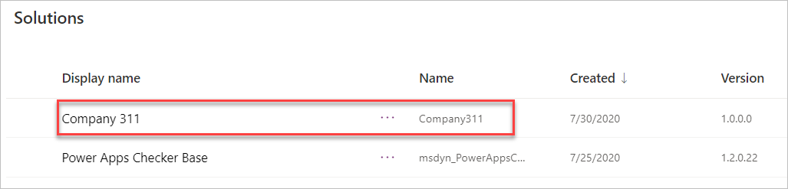](https://github.com/MicrosoftLearning/PL-100-Microsoft-Power-Platform-App-Maker/blob/master/Instructions/Labs/02/media/image4.png)

### Exercise 2: Implement data model

In this exercise, you will create Tables, Columns, and the relationships you identified when you designed the data model for the Company 311 app.

#### Task 1: Create Tables

1. In the [Power Apps maker portal](https://make.powerapps.com/) select **Solutions** and click to open the **Company 311** solution you created in Exercise 1.
2. Click **+ New** and select **Table**.
3. Enter **Building** for **Display name** and click **Create**.

[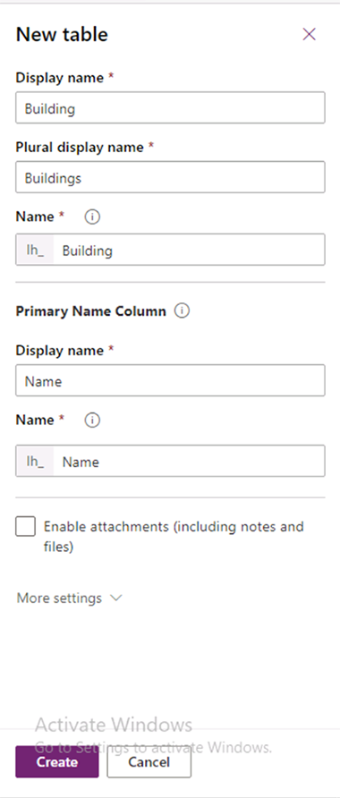](https://github.com/MicrosoftLearning/PL-100-Microsoft-Power-Platform-App-Maker/blob/master/Instructions/Labs/02/media/image5.png)

1. Go back to the solution by clicking on the solution name.
2. Click **+ New** and select **Table** again.
3. Enter **Department** for **Display name** and click **Create**.

[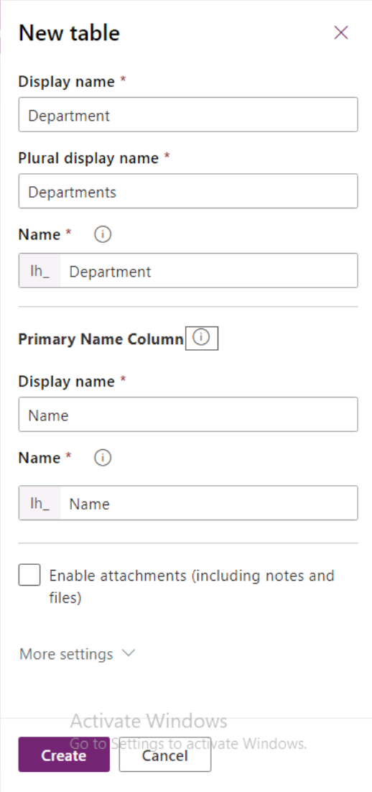](https://github.com/MicrosoftLearning/PL-100-Microsoft-Power-Platform-App-Maker/blob/master/Instructions/Labs/02/media/image7.png)

1. Go back to the solution by clicking on the solution name.
2. Click **+ New** and select **Table** one more time.
3. Enter **Problem Report** for **Display name**, change the **Primary Column** **Display name** to **Title**, and click **More settings**.

[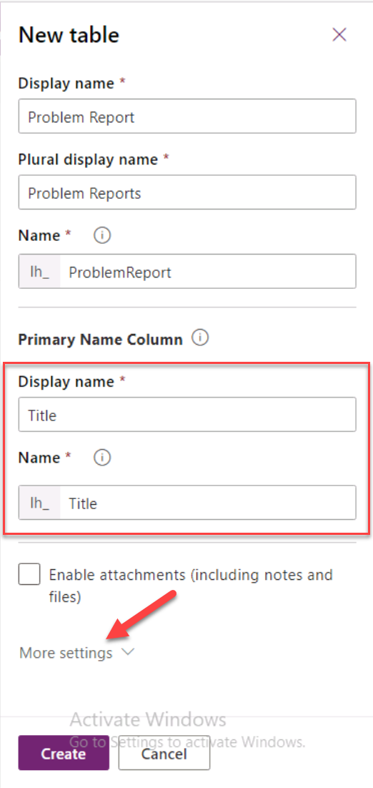](https://github.com/MicrosoftLearning/PL-100-Microsoft-Power-Platform-App-Maker/blob/master/Instructions/Labs/02/media/image8.png)

1. Click to expand the **Collaboration** section.

[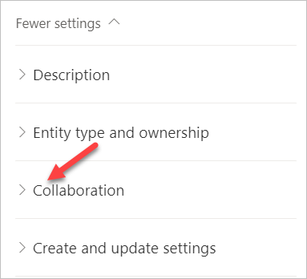](https://github.com/MicrosoftLearning/PL-100-Microsoft-Power-Platform-App-Maker/blob/master/Instructions/Labs/02/media/image9.png)

1. Check the **Enable queues** checkbox and click **Create**. Enabling queues allows Problem Report Rows to be associated with one or more queues to help facilitate routing to the different departments.

[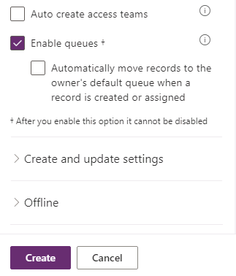](https://github.com/MicrosoftLearning/PL-100-Microsoft-Power-Platform-App-Maker/blob/master/Instructions/Labs/02/media/image10.png)

1. Click **Okay** on the **Confirm changes** popup.

[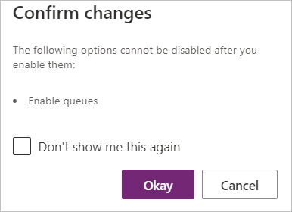](https://github.com/MicrosoftLearning/PL-100-Microsoft-Power-Platform-App-Maker/blob/master/Instructions/Labs/02/media/image11.png)

#### Task 2: Add Columns

In this task, you will add Columns to the Problem Report Table.

1. Navigate to the [Power Apps maker portal](https://make.powerapps.com/) page and make sure you are in the correct environment.
2. Select **Solutions** and click to open the **Company 311** solution you created in exercise 1.
3. Locate and click to open the **Problem Report** Table.

[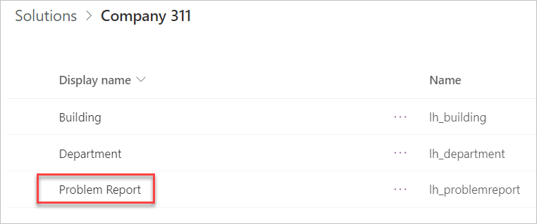](https://github.com/MicrosoftLearning/PL-100-Microsoft-Power-Platform-App-Maker/blob/master/Instructions/Labs/02/media/image12.png)

1. Select the **Columns** tab and click **+ Add Column**.

[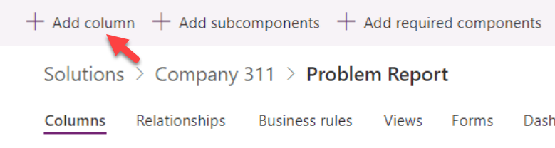](https://github.com/MicrosoftLearning/PL-100-Microsoft-Power-Platform-App-Maker/blob/master/Instructions/Labs/02/media/image13.png)

1. Enter **Location** for **Display name**, select **Text** for **Data type**, and click **Advanced options**.

[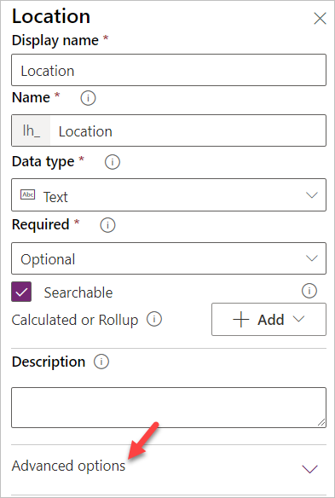](https://github.com/MicrosoftLearning/PL-100-Microsoft-Power-Platform-App-Maker/blob/master/Instructions/Labs/02/media/image14.png)

1. Change **Max length** to **150** and click **Done**.

[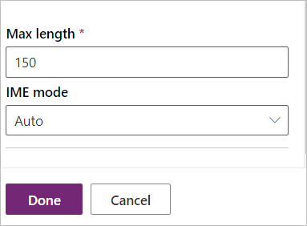](https://github.com/MicrosoftLearning/PL-100-Microsoft-Power-Platform-App-Maker/blob/master/Instructions/Labs/02/media/image15.png)

1. Click **+ Add Column** again.
2. Enter **Details** for **Display name**, select **Multiline text** for **Data type**, make the Column **Required**, and click **Done**.

[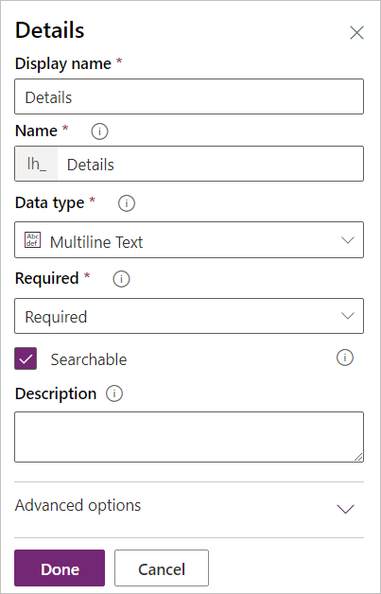](https://github.com/MicrosoftLearning/PL-100-Microsoft-Power-Platform-App-Maker/blob/master/Instructions/Labs/02/media/image16.png)

1. Click **+ Add Column** again.
2. Enter **Photo** for **Display name**, select **Image** for **Data type**, and click **Done**.
3. Click **+ Add Column**.
4. Enter **Resolution** for **Display name**, select **Multiline text** for **Data type**, and click **Done**.
5. Click **+ Add Column**.
6. Enter **Resolved On** for **Display name**, select **Date and time** for **Data type**, and click **Done**.
7. Click **Default** Filter and select Custom

[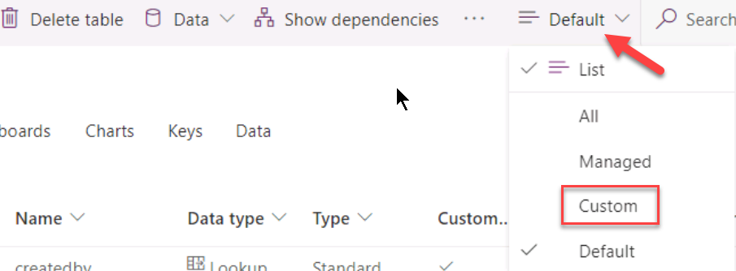](https://github.com/MicrosoftLearning/PL-100-Microsoft-Power-Platform-App-Maker/blob/master/Instructions/Labs/02/media/image17.png)

1. You should now see the 5 new Columns you created. Click **Save Table**.

[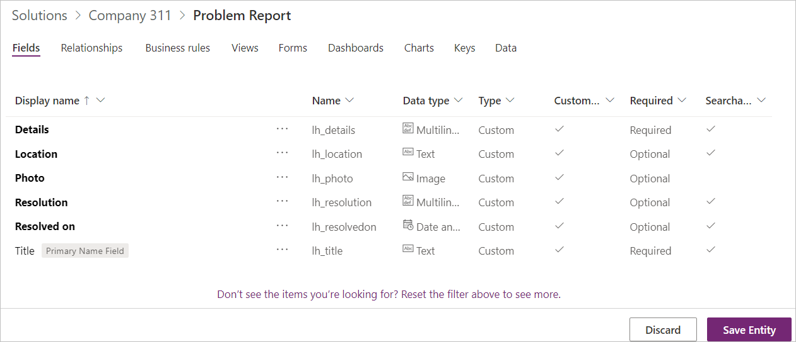](https://github.com/MicrosoftLearning/PL-100-Microsoft-Power-Platform-App-Maker/blob/master/Instructions/Labs/02/media/image18.png)

1. Go back to the solution by clicking on the solution name.
2. Click **Publish all customizations** and wait for the publishing to complete.
3. Do not navigate away from this page until all customizations have been published successfully.

#### Task 3: Edit status reason Choice

In this task, you will edit the status reason Column of the problem report Table.

1. Make sure you are in the **Company 311** solution.
2. Click to open the **Problem Report** Table.
3. Click on the **… More commands** button and select **Switch to classic**.

[!NOTE]  
You are switching to classic because the modern solution explorer does not support editing status reason yet but will in the future.

[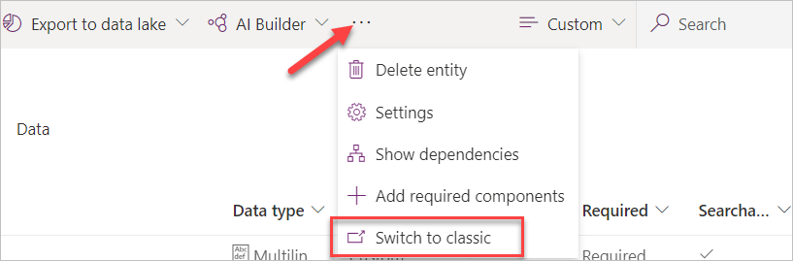](https://github.com/MicrosoftLearning/PL-100-Microsoft-Power-Platform-App-Maker/blob/master/Instructions/Labs/02/media/image19.png)

1. Select **Fields** and double click to open the **Status Reason** Column.

[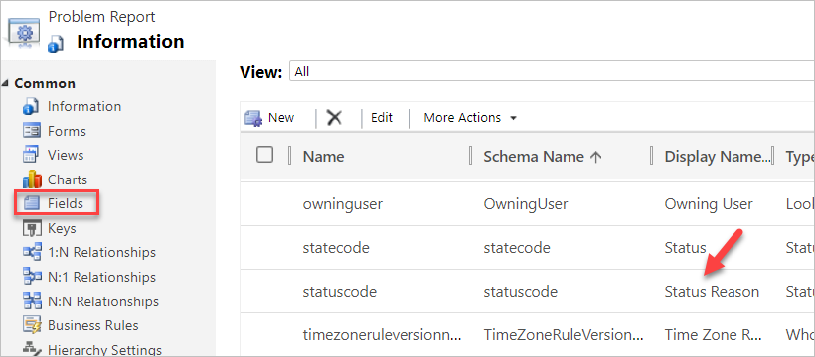](https://github.com/MicrosoftLearning/PL-100-Microsoft-Power-Platform-App-Maker/blob/master/Instructions/Labs/02/media/image20.png)

1. Make sure **Active** is selected for **Status** and double click to open the **Active** option.

[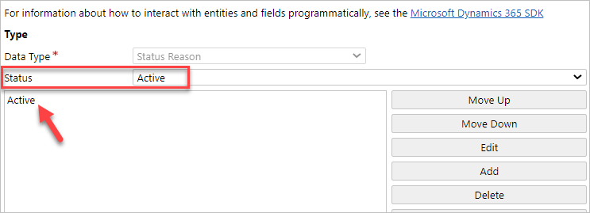](https://github.com/MicrosoftLearning/PL-100-Microsoft-Power-Platform-App-Maker/blob/master/Instructions/Labs/02/media/image21.png)

1. Change the **Label** value to **New** and click **OK**.

[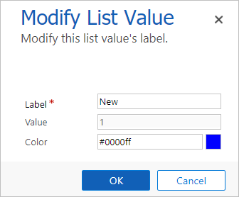](https://github.com/MicrosoftLearning/PL-100-Microsoft-Power-Platform-App-Maker/blob/master/Instructions/Labs/02/media/image22.png)

1. Click **Add**.

[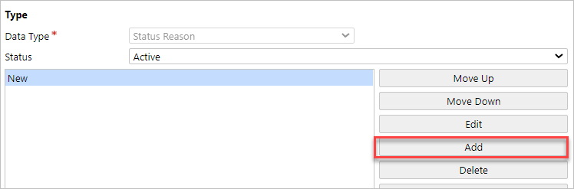](https://github.com/MicrosoftLearning/PL-100-Microsoft-Power-Platform-App-Maker/blob/master/Instructions/Labs/02/media/image23.png)

1. Enter Assigned for Label and click OK.

[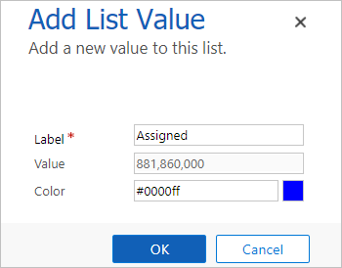](https://github.com/MicrosoftLearning/PL-100-Microsoft-Power-Platform-App-Maker/blob/master/Instructions/Labs/02/media/image24.png)

1. Click **Add** again.
2. Enter **In Progress** for **Label** and click **OK**.
3. Click **Add** again.
4. Enter **Completed** for **Label** and click **OK**.
5. Click **Add** one more time.
6. Enter **Won’t Fix** for **Label** and click **OK**.
7. You should now have 5 options. Select **New** for **Default Value** and click **Save and Close**.

[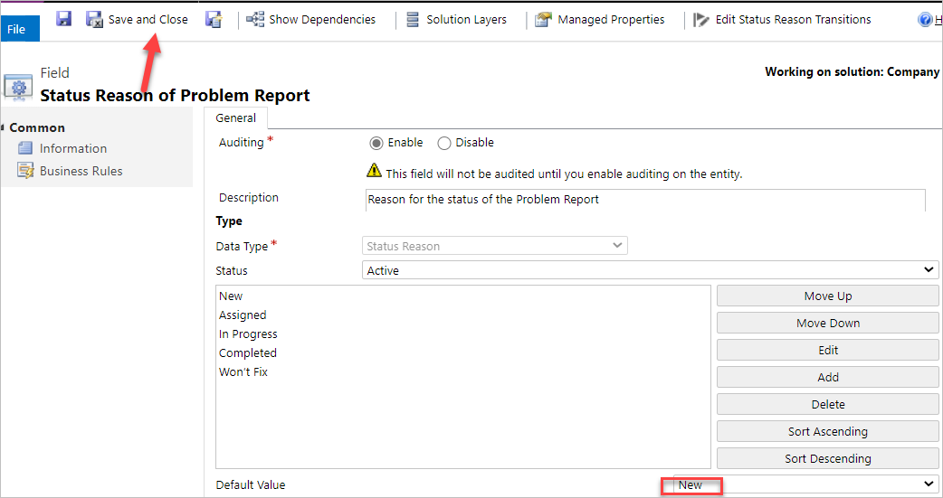](https://github.com/MicrosoftLearning/PL-100-Microsoft-Power-Platform-App-Maker/blob/master/Instructions/Labs/02/media/image25.png)

1. Click **Publish** and wait for the publishing to complete.
2. Click Save and Close to close the classic editor.
3. You should now be back on the **Power Apps Maker** portal.

[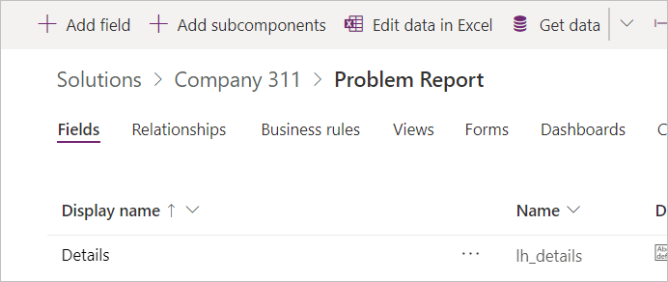](https://github.com/MicrosoftLearning/PL-100-Microsoft-Power-Platform-App-Maker/blob/master/Instructions/Labs/02/media/image26.png)

#### Task 4: Relationships

In this task, you will create many to one relationships between the problem report Table and the building and department Tables.

1. Make sure you are in the **Problem Report** Table.
2. Select the **Relationships** tab and click **+ Add relationship**.

[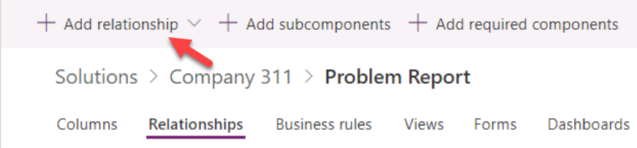](https://github.com/MicrosoftLearning/PL-100-Microsoft-Power-Platform-App-Maker/blob/master/Instructions/Labs/02/media/image27.png)

1. Select **Many-to-one**.

[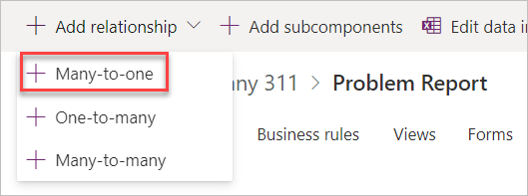](https://github.com/MicrosoftLearning/PL-100-Microsoft-Power-Platform-App-Maker/blob/master/Instructions/Labs/02/media/image28.png)

1. Select **Building** for **Related (One) Table** and click **Done**.

[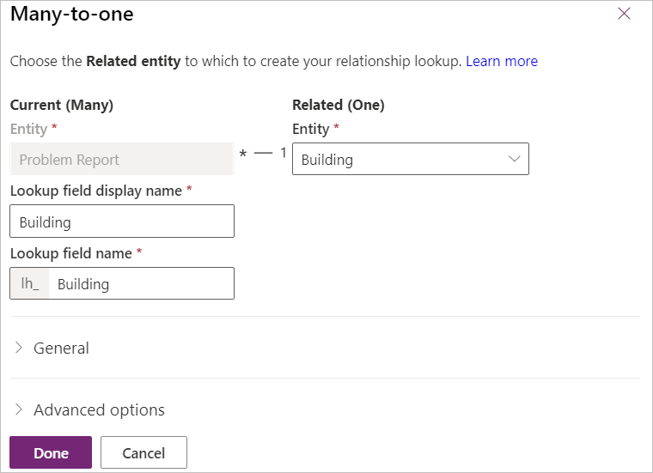](https://github.com/MicrosoftLearning/PL-100-Microsoft-Power-Platform-App-Maker/blob/master/Instructions/Labs/02/media/image29.png)

1. Click **+ Add relationship** again.
2. Select **Many-to-one**.
3. Select **Department** for **Related (One) Table** and click **Done**.
4. Click **Save Table**.
5. Go back to the solution by clicking on the solution name.
6. Click **Publish all customizations** and wait for the publishing to complete.

### Exercise 3: Configure form and views

In this exercise, you will configure form and views for the problem report Table.

#### Task 1: Configure form

1. Navigate to the [Power Apps maker portal](https://make.powerapps.com/) and make sure you are in the correct environment.
2. Select Solutions and click to open the **Company 311** solution.
3. Locate and click to open the **Problem Report** Table.
4. Select the **Forms** tab and click to open the **Main** form.

[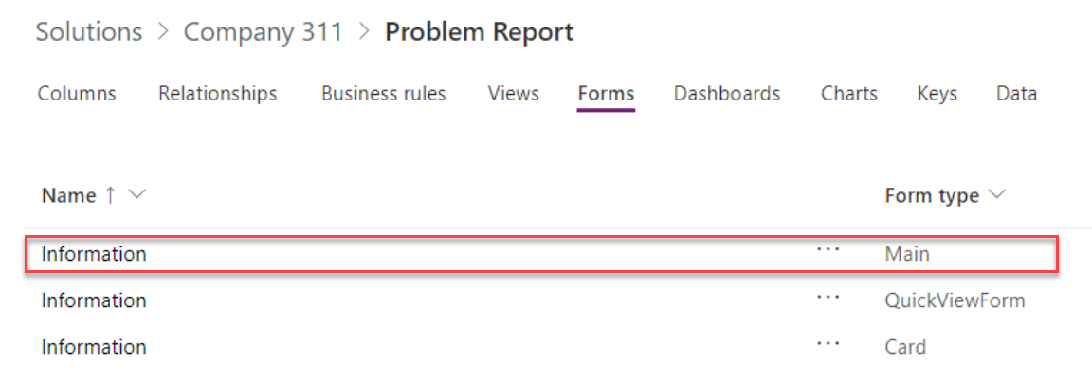](https://github.com/MicrosoftLearning/PL-100-Microsoft-Power-Platform-App-Maker/blob/master/Instructions/Labs/02/media/image30.png)

1. Use the Zoom control at the bottom of the form to make the form large enough for you to work easily. Select the form section.

[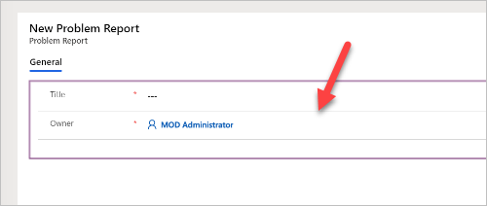](https://github.com/MicrosoftLearning/PL-100-Microsoft-Power-Platform-App-Maker/blob/master/Instructions/Labs/02/media/image31.png)

1. Go to the **Properties** pane, change the **Label** to **Problem details**, and enter **section_problem_report** for **Name**.

[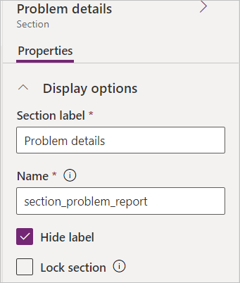](https://github.com/MicrosoftLearning/PL-100-Microsoft-Power-Platform-App-Maker/blob/master/Instructions/Labs/02/media/image32.png)

1. While you still have the section selected, go to the **Columns** pane, and click on the **Building** Column. The Building Column will be added to the form.

[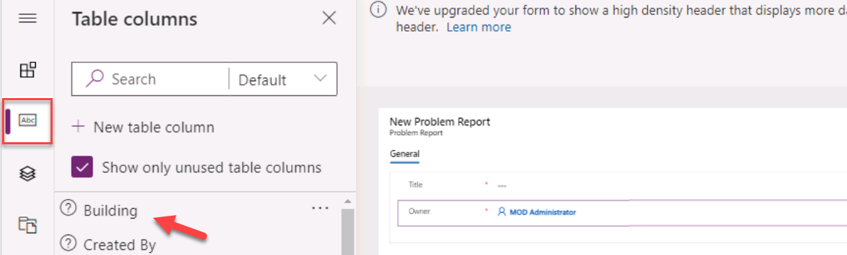](https://github.com/MicrosoftLearning/PL-100-Microsoft-Power-Platform-App-Maker/blob/master/Instructions/Labs/02/media/image33.png)

1. Add the **Details**, and **Photo** Columns to the form.
2. Your form should now look like the image below. Select the **Details** Column.

[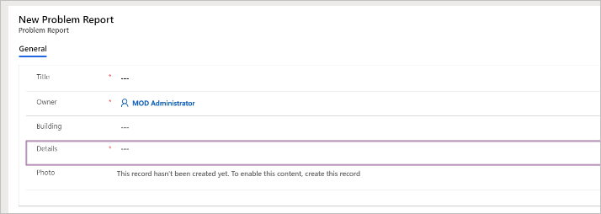](https://github.com/MicrosoftLearning/PL-100-Microsoft-Power-Platform-App-Maker/blob/master/Instructions/Labs/02/media/image34.png)

1. Go to the **Properties** pane and click to expand the **Formatting** section.

[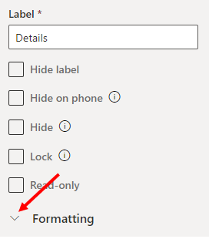](https://github.com/MicrosoftLearning/PL-100-Microsoft-Power-Platform-App-Maker/blob/master/Instructions/Labs/02/media/image35.png)

1. Change the **Column height** to **4**.

[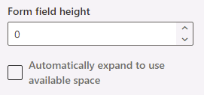](https://github.com/MicrosoftLearning/PL-100-Microsoft-Power-Platform-App-Maker/blob/master/Instructions/Labs/02/media/image36.png)

1. Select the **Components** from the toolbar.

[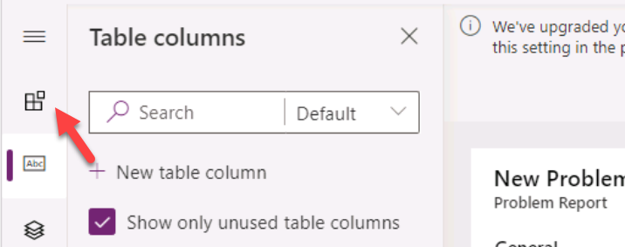](https://github.com/MicrosoftLearning/PL-100-Microsoft-Power-Platform-App-Maker/blob/master/Instructions/Labs/02/media/image37.png)

1. Select **1-Column section.**

[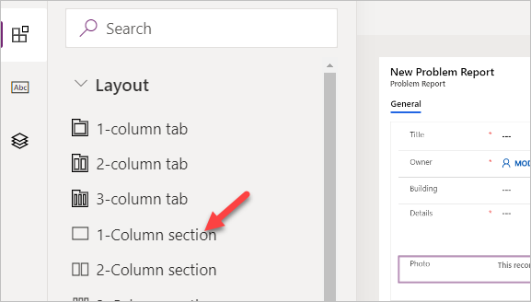](https://github.com/MicrosoftLearning/PL-100-Microsoft-Power-Platform-App-Maker/blob/master/Instructions/Labs/02/media/image38.png)

1. A new section should be added to the form. Select the new section.

[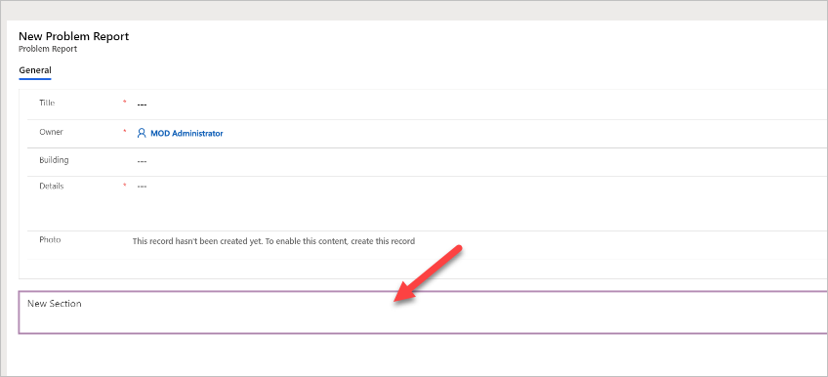](https://github.com/MicrosoftLearning/PL-100-Microsoft-Power-Platform-App-Maker/blob/master/Instructions/Labs/02/media/image39.png)

1. Go to the **Properties** pane, change the **Section label** to **Resolution details**, and enter **section_resolution_details** for **Name**.

[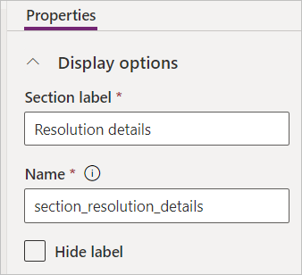](https://github.com/MicrosoftLearning/PL-100-Microsoft-Power-Platform-App-Maker/blob/master/Instructions/Labs/02/media/image40.png)

1. Select **Table columns** from the toolbar.
2. Add **Department**, **Status Reason**, **Resolved on**, and **Resolution** Columns to the **Resolution details** section.

[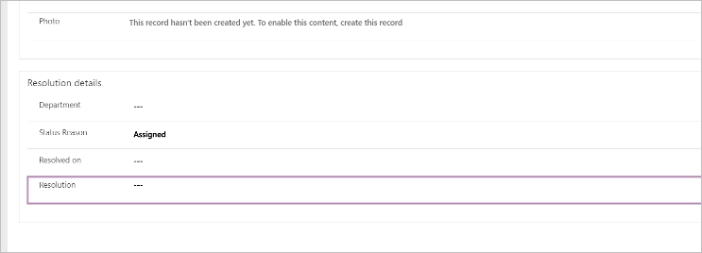](https://github.com/MicrosoftLearning/PL-100-Microsoft-Power-Platform-App-Maker/blob/master/Instructions/Labs/02/media/image41.png)

1. Select the **Resolution** Column.
2. Go to the **Properties** pane and click to expand the **Formatting** section.
3. Change the **Column height** to **4**.
4. You form should now look like the image below. Click **Save**.

[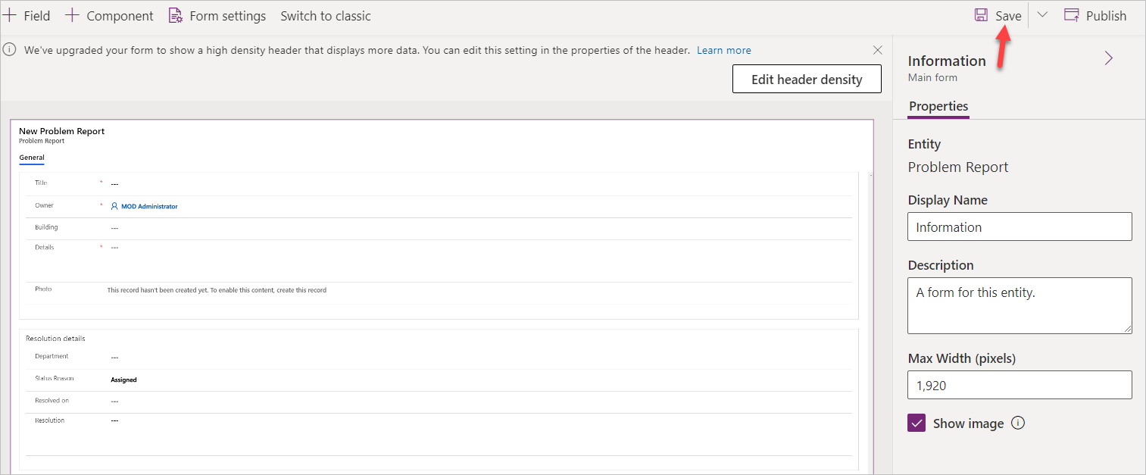](https://github.com/MicrosoftLearning/PL-100-Microsoft-Power-Platform-App-Maker/blob/master/Instructions/Labs/02/media/image42.png)

1. Click **Publish** and wait for the publishing to complete.
2. Click on the **<- Back** button.

[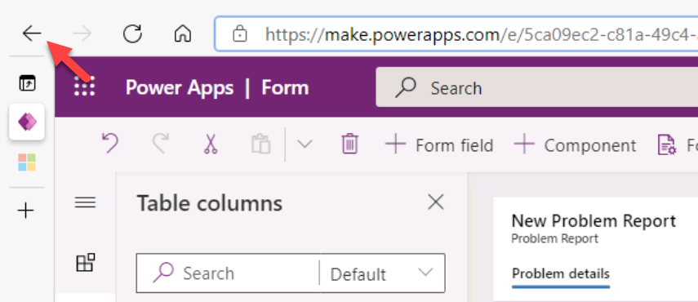](https://github.com/MicrosoftLearning/PL-100-Microsoft-Power-Platform-App-Maker/blob/master/Instructions/Labs/02/media/image43.png)

1. You should now be back to the Table.

#### Task 2: Edit view

1. Select the **Views** tab and click to open the **Active Problem Reports** view.

[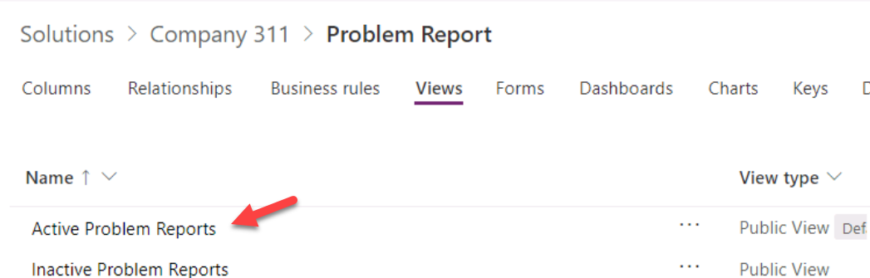](https://github.com/MicrosoftLearning/PL-100-Microsoft-Power-Platform-App-Maker/blob/master/Instructions/Labs/02/media/image44.png)

1. Click **+ View column** and select **Building** to add the **Building** column to the view.

[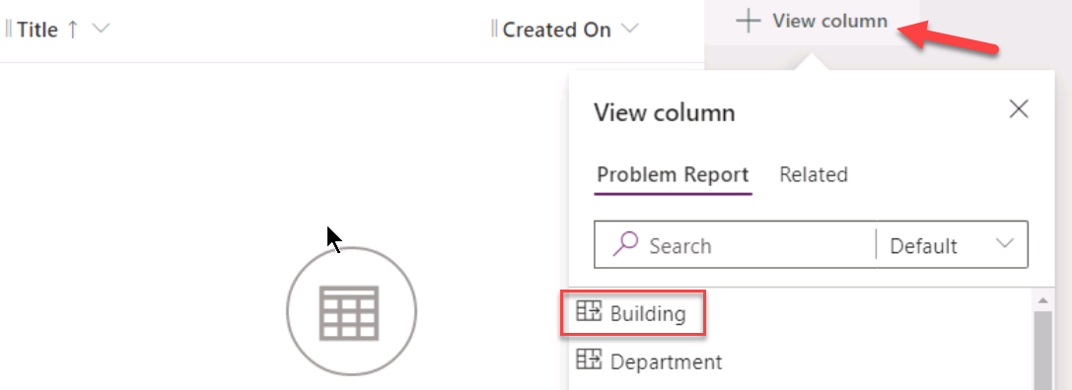](https://github.com/MicrosoftLearning/PL-100-Microsoft-Power-Platform-App-Maker/blob/master/Instructions/Labs/02/media/image45.png)

1. Add **Location**, **Status Reason**, and **Owner** columns to the view. You will have to change the column filter to All when adding status reason and owner columns.

[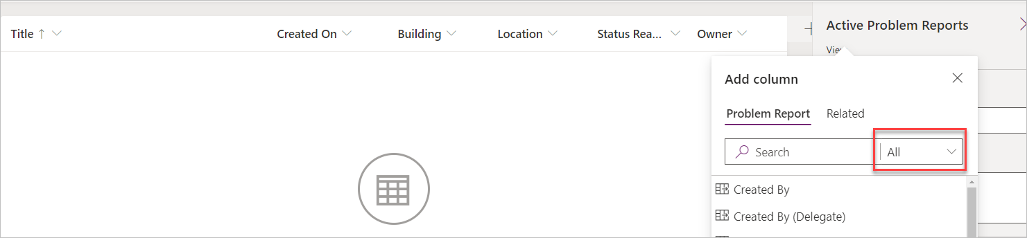](https://github.com/MicrosoftLearning/PL-100-Microsoft-Power-Platform-App-Maker/blob/master/Instructions/Labs/02/media/image46.png)

1. Go to the view properties pane and click **Edit filters**.

[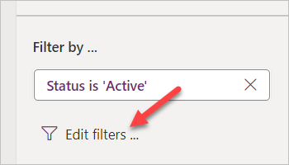](https://github.com/MicrosoftLearning/PL-100-Microsoft-Power-Platform-App-Maker/blob/master/Instructions/Labs/02/media/image47.png)

1. Set the first filter to **Status Reason Equals New**.
2. Click on the Column where **New** is selected.

[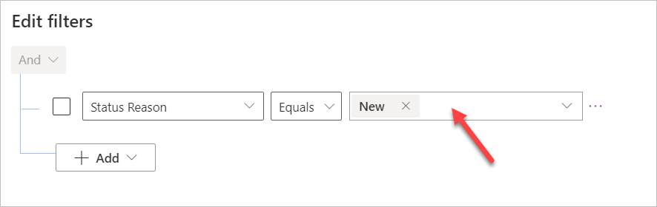](https://github.com/MicrosoftLearning/PL-100-Microsoft-Power-Platform-App-Maker/blob/master/Instructions/Labs/02/media/image48.png)

1. Select **Assigned**.

[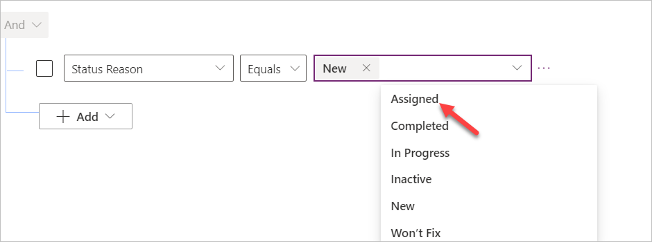](https://github.com/MicrosoftLearning/PL-100-Microsoft-Power-Platform-App-Maker/blob/master/Instructions/Labs/02/media/image49.png)

1. Click on the column again and select **In progress**.
2. The filter should now look like the image below. Click **OK**.

[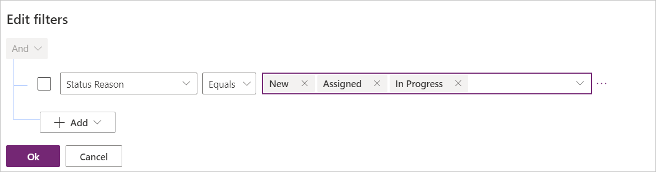](https://github.com/MicrosoftLearning/PL-100-Microsoft-Power-Platform-App-Maker/blob/master/Instructions/Labs/02/media/image50.png)

1. Click **Save**.

#### Task 3: Create view from existing

In this task, you will create a new view from the Active Problem Reports view.

1. Click **Edit filters**.

[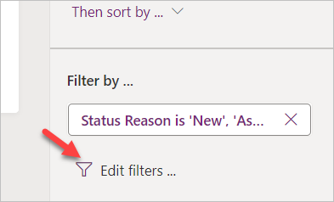](https://github.com/MicrosoftLearning/PL-100-Microsoft-Power-Platform-App-Maker/blob/master/Instructions/Labs/02/media/image51.png)

1. Remove **In Progress** from the filter.

[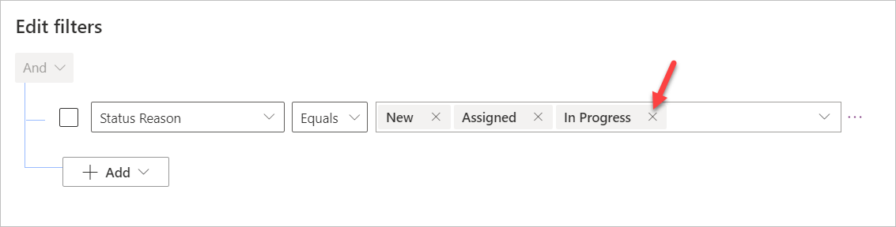](https://github.com/MicrosoftLearning/PL-100-Microsoft-Power-Platform-App-Maker/blob/master/Instructions/Labs/02/media/image52.png)

1. Remove **Assigned** and **New** values form the filter.
2. Select **Completed**.

[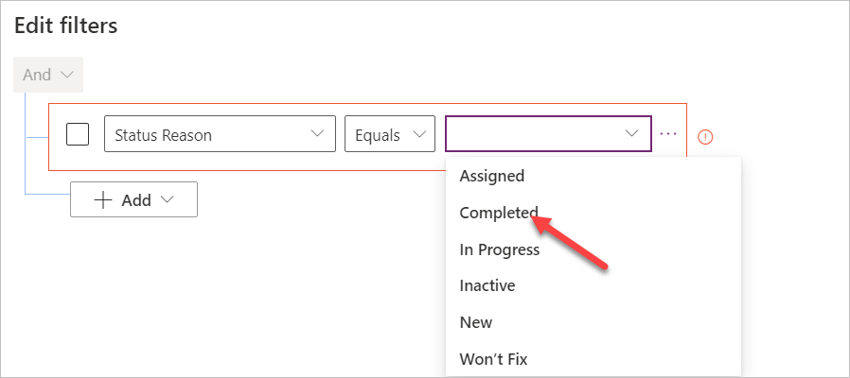](https://github.com/MicrosoftLearning/PL-100-Microsoft-Power-Platform-App-Maker/blob/master/Instructions/Labs/02/media/image53.png)

1. Add **Won’t Fix** and **Inactive** values to filter.
2. The filter should now look like the image below. Click **OK**.

[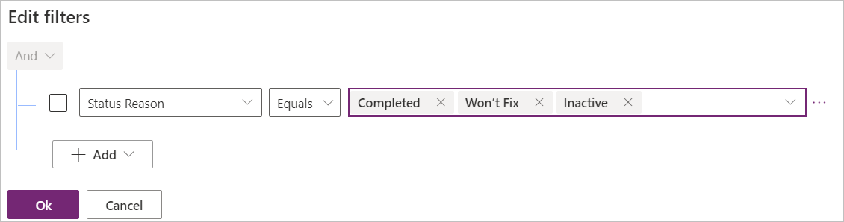](https://github.com/MicrosoftLearning/PL-100-Microsoft-Power-Platform-App-Maker/blob/master/Instructions/Labs/02/media/image54.png)

1. Click on the chevron button next to the save button and select **Save As**.

[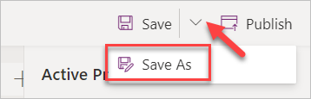](https://github.com/MicrosoftLearning/PL-100-Microsoft-Power-Platform-App-Maker/blob/master/Instructions/Labs/02/media/image55.png)

1. Enter **Resolved Problems** for **Name** and click **Save**.

[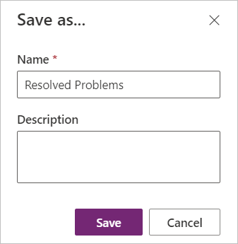](https://github.com/MicrosoftLearning/PL-100-Microsoft-Power-Platform-App-Maker/blob/master/Instructions/Labs/02/media/image56.png)

1. Click on the **<-Back Button**.

[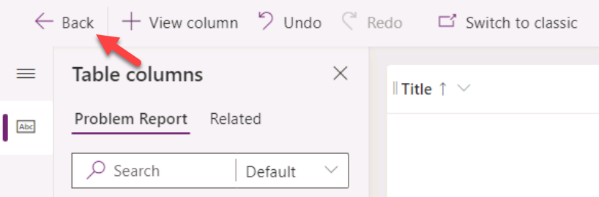](https://github.com/MicrosoftLearning/PL-100-Microsoft-Power-Platform-App-Maker/blob/master/Instructions/Labs/02/media/image57.png)

1. Go to the solution by clicking on the solution name.

[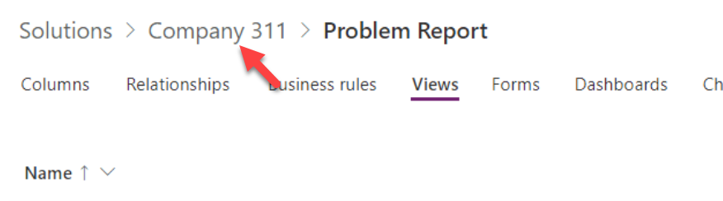](https://github.com/MicrosoftLearning/PL-100-Microsoft-Power-Platform-App-Maker/blob/master/Instructions/Labs/02/media/image58.png)

1. Click **Publish all customizations** and wait for the publishing to complete.

[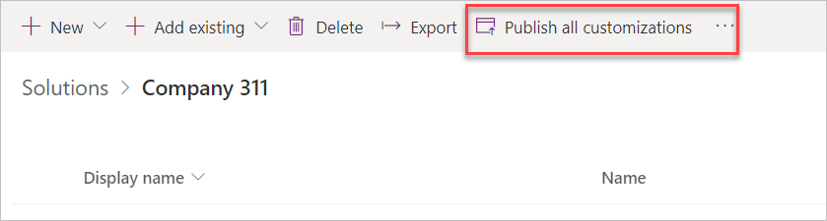](https://github.com/MicrosoftLearning/PL-100-Microsoft-Power-Platform-App-Maker/blob/master/Instructions/Labs/02/media/image59.png)

### Exercise 4: Compose model-driven application

In this exercise, you will create model-driven application.

#### Task 1: Create new model-driven application

1. Navigate to the [Power Apps maker portal](https://make.powerapps.com/) and make sure you are in the correct environment.
2. Select Solutions and click to open the **Company 311** solution.
3. Click **+ New | App | Model-driven app**.

[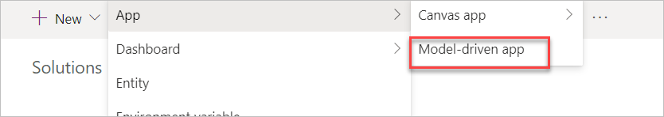](https://github.com/MicrosoftLearning/PL-100-Microsoft-Power-Platform-App-Maker/blob/master/Instructions/Labs/02/media/image60.png)

1. Enter **Company 311 Admin** for name and click **Done**.

[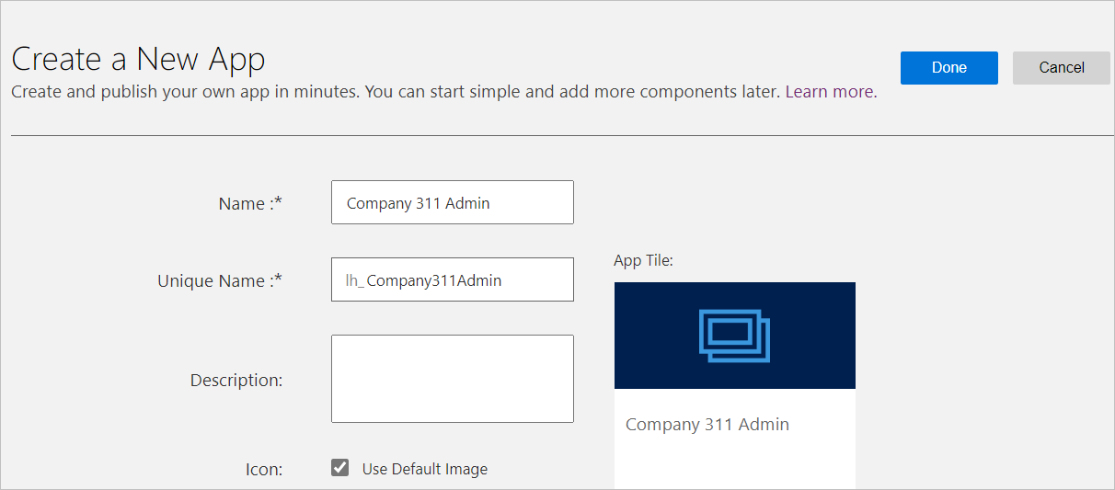](https://github.com/MicrosoftLearning/PL-100-Microsoft-Power-Platform-App-Maker/blob/master/Instructions/Labs/02/media/image61.png)

1. Click Edit **Site Map.**

[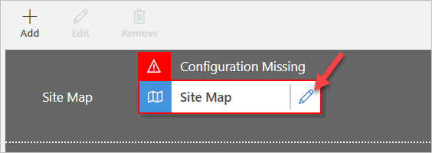](https://github.com/MicrosoftLearning/PL-100-Microsoft-Power-Platform-App-Maker/blob/master/Instructions/Labs/02/media/image62.png)

1. Select the **New Area**.

[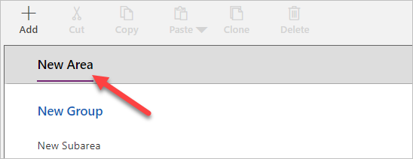](https://github.com/MicrosoftLearning/PL-100-Microsoft-Power-Platform-App-Maker/blob/master/Instructions/Labs/02/media/image63.png)

1. Go to the **Properties** pane, enter **Manage Problems** for **Title**, and enter **area_manage_problems** for **ID**.

[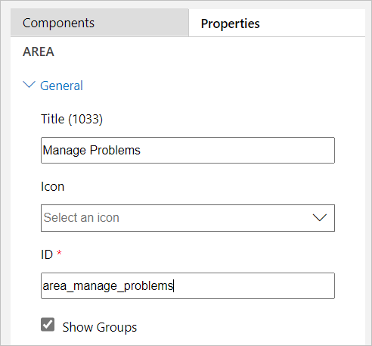](https://github.com/MicrosoftLearning/PL-100-Microsoft-Power-Platform-App-Maker/blob/master/Instructions/Labs/02/media/image64.png)

1. Select the **New Group**.

[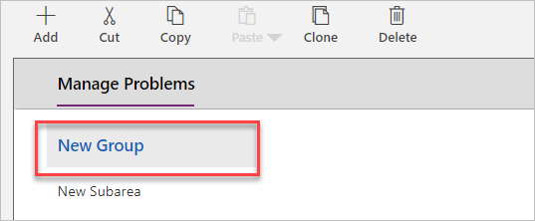](https://github.com/MicrosoftLearning/PL-100-Microsoft-Power-Platform-App-Maker/blob/master/Instructions/Labs/02/media/image65.png)

1. Go to the **Properties**, enter **Problems** for **Title**, and enter **group_problems** for **ID**.

[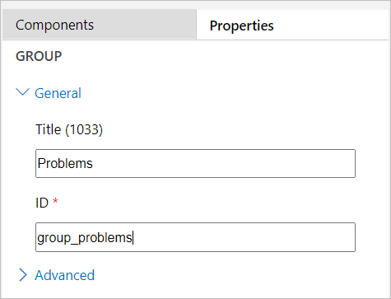](https://github.com/MicrosoftLearning/PL-100-Microsoft-Power-Platform-App-Maker/blob/master/Instructions/Labs/02/media/image66.png)

1. Select the **New Subarea**.

[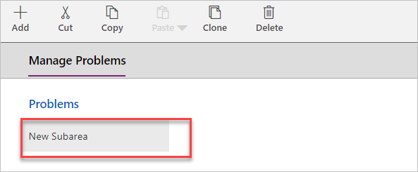](https://github.com/MicrosoftLearning/PL-100-Microsoft-Power-Platform-App-Maker/blob/master/Instructions/Labs/02/media/image67.png)

1. Go to the **Properties** pane, select **Table** for **Type**, and select **Problem Report** for **Table**.

[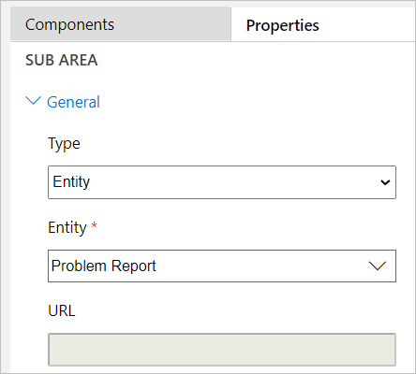](https://github.com/MicrosoftLearning/PL-100-Microsoft-Power-Platform-App-Maker/blob/master/Instructions/Labs/02/media/image68.png)

1. Click **+ Add**.

[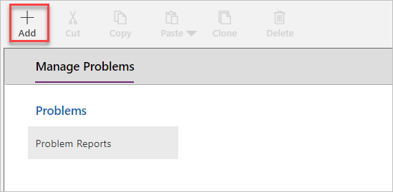](https://github.com/MicrosoftLearning/PL-100-Microsoft-Power-Platform-App-Maker/blob/master/Instructions/Labs/02/media/image69.png)

1. Select **Area**.
2. Select the **New Area** you just added.

[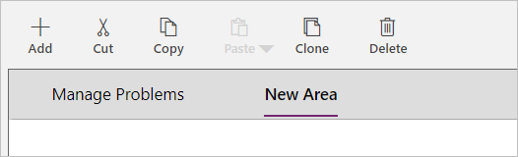](https://github.com/MicrosoftLearning/PL-100-Microsoft-Power-Platform-App-Maker/blob/master/Instructions/Labs/02/media/image70.png)

1. Go to the **Properties** pane, enter **Settings** for **Title**, and enter **area_settings** for **ID**.
2. Select the **Settings** area and click **+ Add**.

[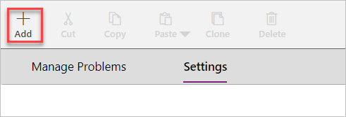](https://github.com/MicrosoftLearning/PL-100-Microsoft-Power-Platform-App-Maker/blob/master/Instructions/Labs/02/media/image71.png)

1. Select **Group**.
2. Select the **New Group** you just added.
3. Go to the **Properties** pane, enter **Taxonomy** for **Title**, and enter **group_taxonomy** for **ID**.

[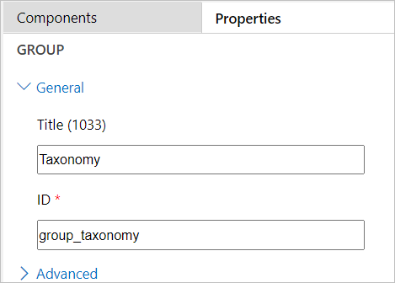](https://github.com/MicrosoftLearning/PL-100-Microsoft-Power-Platform-App-Maker/blob/master/Instructions/Labs/02/media/image72.png)

1. Select the **Taxonomy** group you just added and select the **Components** pane.

[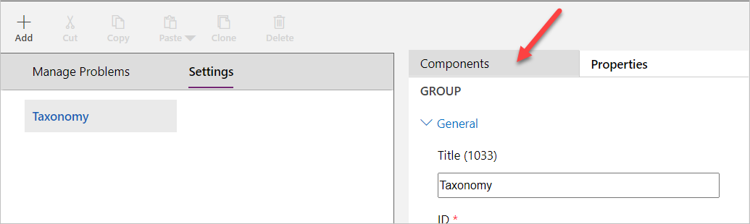](https://github.com/MicrosoftLearning/PL-100-Microsoft-Power-Platform-App-Maker/blob/master/Instructions/Labs/02/media/image73.png)

1. Drag **Subarea** and drop it under the **Taxonomy** group.

[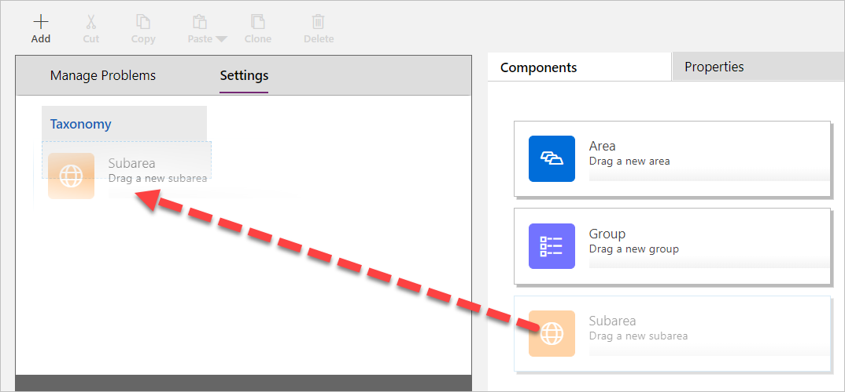](https://github.com/MicrosoftLearning/PL-100-Microsoft-Power-Platform-App-Maker/blob/master/Instructions/Labs/02/media/image74.png)

1. Select the **New Subarea**.
2. Go to the **Properties** pane, select **Entity** for **Type**, and select **Building** for **Table**.

[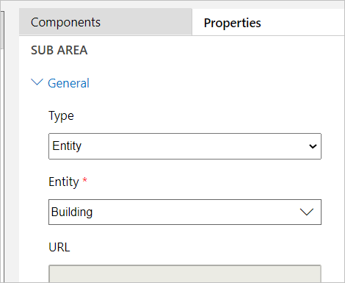](https://github.com/MicrosoftLearning/PL-100-Microsoft-Power-Platform-App-Maker/blob/master/Instructions/Labs/02/media/image75.png)

1. Add another **Subarea** component to the **Taxonomy** group.
2. Select the **New Subarea**.
3. Go to the **Properties** pane, select **Table** for **Type**, and select **Department** for **Table**.
4. The sitemap should now look like the image below. Click **Save** to save the sitemap.

[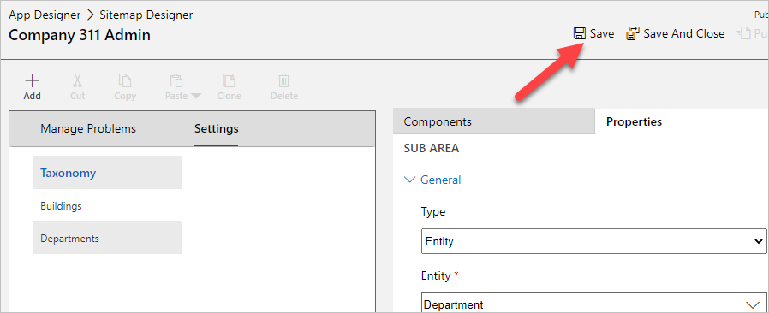](https://github.com/MicrosoftLearning/PL-100-Microsoft-Power-Platform-App-Maker/blob/master/Instructions/Labs/02/media/image76.png)

1. Click **Publish** to publish the sitemap and wait for the publishing to complete.
2. Go back to the **App Designer**.

[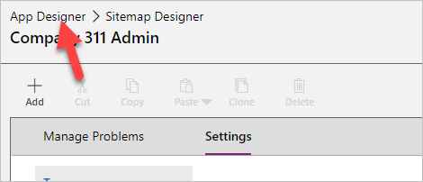](https://github.com/MicrosoftLearning/PL-100-Microsoft-Power-Platform-App-Maker/blob/master/Instructions/Labs/02/media/image77.png)

1. The application should now have three Tables. Click **Save** to save the application.

[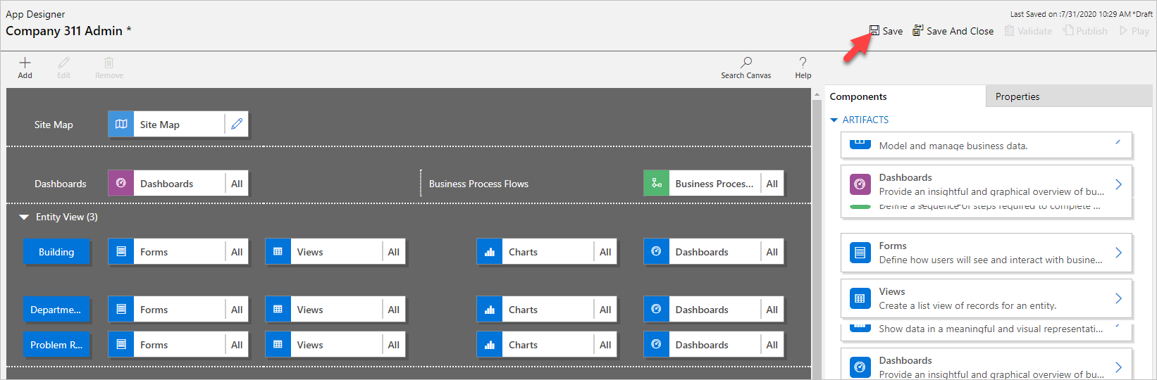](https://github.com/MicrosoftLearning/PL-100-Microsoft-Power-Platform-App-Maker/blob/master/Instructions/Labs/02/media/image78.png)

1. Click **Publish** to publish the application and wait for the publishing to complete.
2. Close the app designer browser tab or window.
3. Click **Done**.

[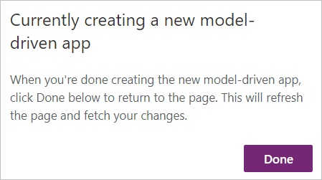](https://github.com/MicrosoftLearning/PL-100-Microsoft-Power-Platform-App-Maker/blob/master/Instructions/Labs/02/media/image79.png)

### Exercise 5: Input data

In this exercise, you will input data.

#### Task 1: Input data

1. Navigate to the [Power Apps maker portal](https://make.powerapps.com/) and make sure you are in the correct environment.
2. Select **Apps** and click to open the **Company 311 Admin** application you created.

[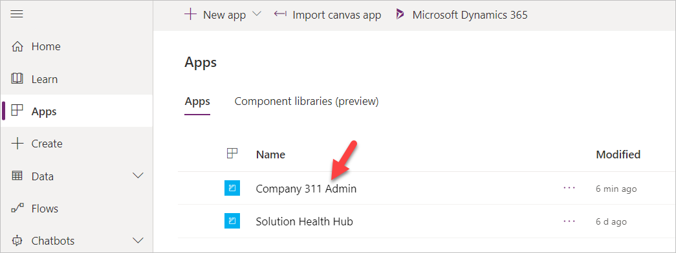](https://github.com/MicrosoftLearning/PL-100-Microsoft-Power-Platform-App-Maker/blob/master/Instructions/Labs/02/media/image80.png)

1. Click **Change area**.

[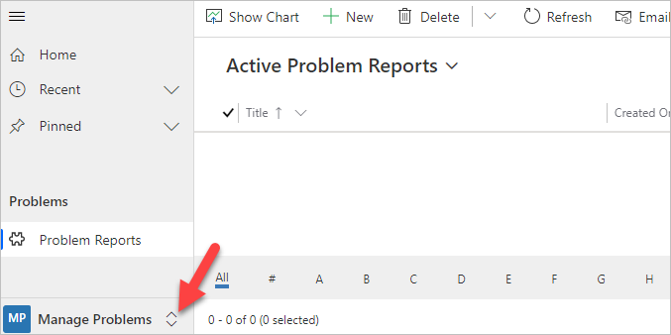](https://github.com/MicrosoftLearning/PL-100-Microsoft-Power-Platform-App-Maker/blob/master/Instructions/Labs/02/media/image81.png)

1. Select **Settings** area.
2. Select **Departments** and click **+ New**.

[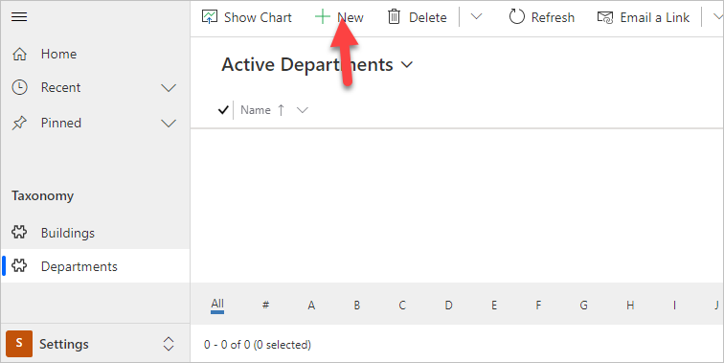](https://github.com/MicrosoftLearning/PL-100-Microsoft-Power-Platform-App-Maker/blob/master/Instructions/Labs/02/media/image82.png)

1. Enter **Facility Maintenance** for **Name** and click **Save**.

[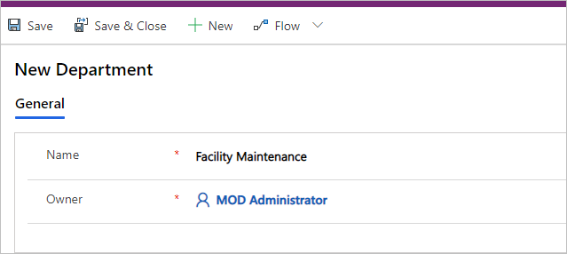](https://github.com/MicrosoftLearning/PL-100-Microsoft-Power-Platform-App-Maker/blob/master/Instructions/Labs/02/media/image83.png)

1. Click **+ New** again.
2. Enter **Human Resources** for **Name** and click **Save**.
3. Click **+ New** one more time.
4. Enter **Marketing** for **Name** and click **Save**.
5. Select **Departments**.
6. You should now have three department Rows. Select **Buildings**.

[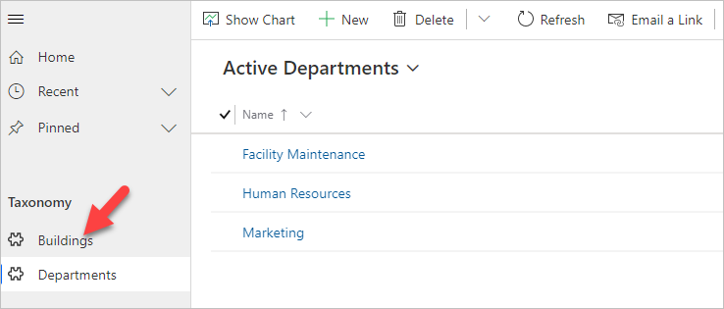](https://github.com/MicrosoftLearning/PL-100-Microsoft-Power-Platform-App-Maker/blob/master/Instructions/Labs/02/media/image84.png)

1. Click **+ New**.
2. Enter **San Francisco Main Campus** for **Name** and click **Save & Close**.
3. Click **+ New** again.
4. Enter **London Paddington** for **Name** and click **Save & Close**.
5. You should now have two building Rows. Click **Change area**.

[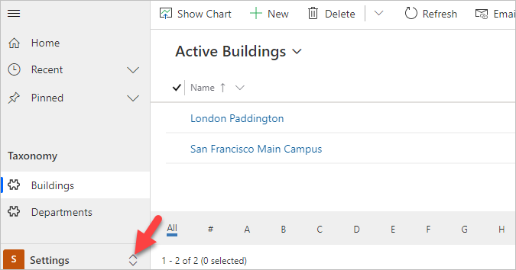](https://github.com/MicrosoftLearning/PL-100-Microsoft-Power-Platform-App-Maker/blob/master/Instructions/Labs/02/media/image85.png)

1. Select **Manage Problems**.
2. Click **+ New**.

[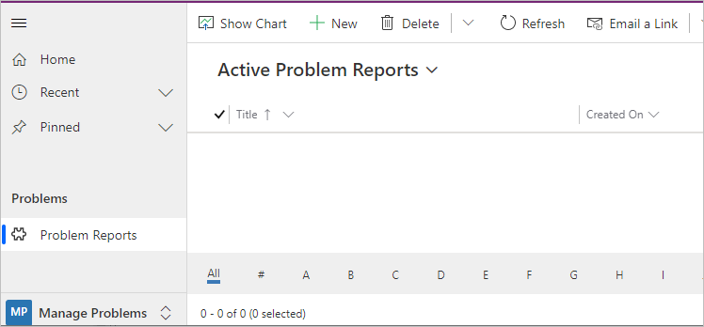](https://github.com/MicrosoftLearning/PL-100-Microsoft-Power-Platform-App-Maker/blob/master/Instructions/Labs/02/media/image86.png)

1. Enter **Broken door** for **Title**, select **San Francisco Main Campus** for **Building**, enter **The main entrance door will not open all the way** for **Details**, and click Save

[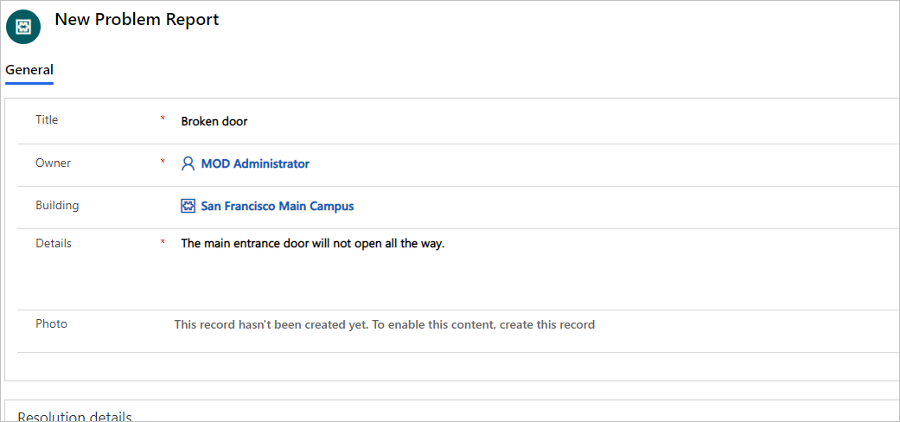](https://github.com/MicrosoftLearning/PL-100-Microsoft-Power-Platform-App-Maker/blob/master/Instructions/Labs/02/media/image87.png)

1. Click on the **Photo** Column.

[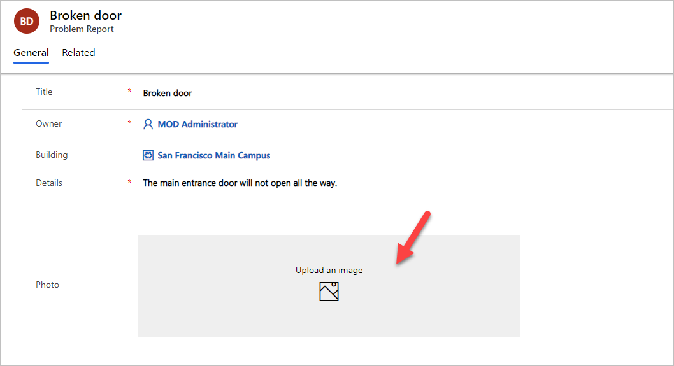](https://github.com/MicrosoftLearning/PL-100-Microsoft-Power-Platform-App-Maker/blob/master/Instructions/Labs/02/media/image88.png)

1. Select an image from your device. The sample imaged displayed below can be found here: image89.png
2. The image should now show on the form.

[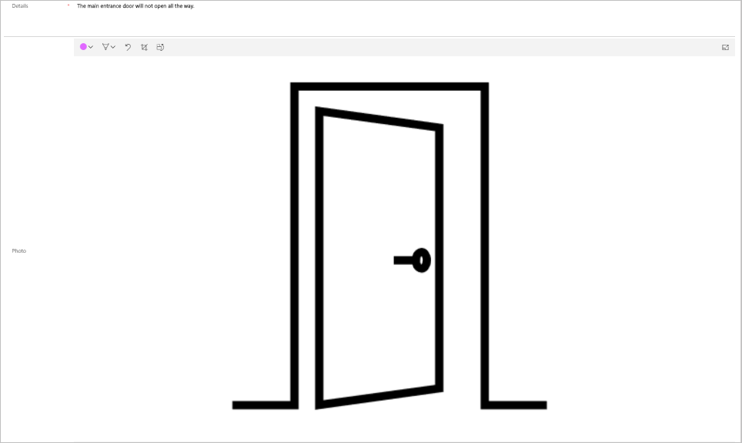](https://github.com/MicrosoftLearning/PL-100-Microsoft-Power-Platform-App-Maker/blob/master/Instructions/Labs/02/media/image89.png)

1. Click **Save & Close**.
2. Close the browser tab.

Then Add some records in **Problem Report** Table